Manual Test Plan

The board should initially look like Figure.1. It asks the player if he/she wants to start the game.

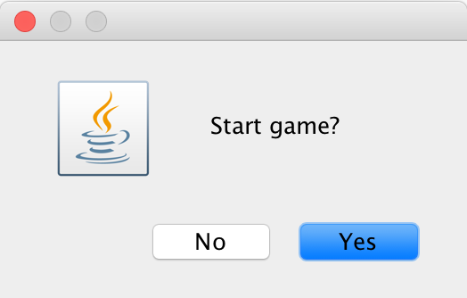

Figure.1

After pressing "Yes" in Figure.1, the player should expect to see a board looks like Figure.2. It asks the player to choose the board size they want to play with. All options are showed in Figure.3.

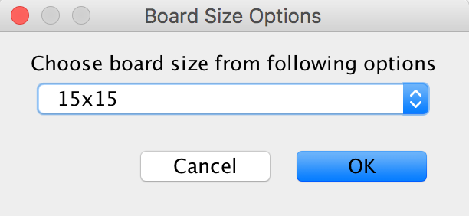

Figure.2

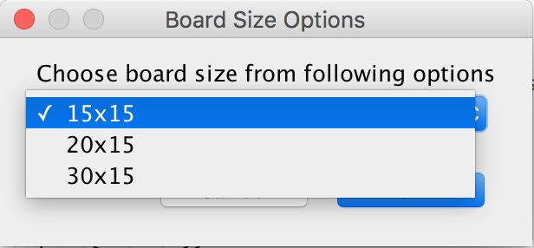

Figure.3

After choosing the desired board size (assume we choose 20x15 here), a game board looks like Figure.4 shows up. The green rectangular represent the player, the red rectangular represent the enemy (any of the enemy can eat the player), the blue rectangular represent walls and the yellow dot represent coins. The initial score is 0 because the player has not eaten any coin yet.

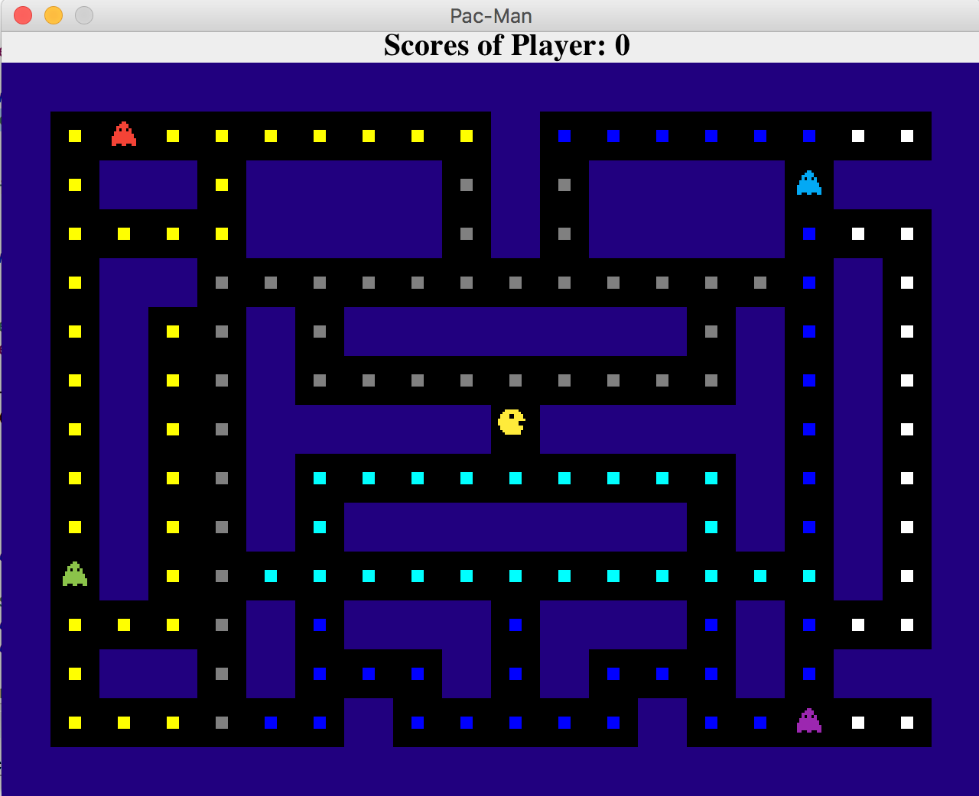

Figure.4

Then the game will immediately start, and the four enemies will take a random move after each 0.6 second. After a short period of time, the board will look like Figure.5. At that point, the player will not move because the user has not pressed any button on keyboard.

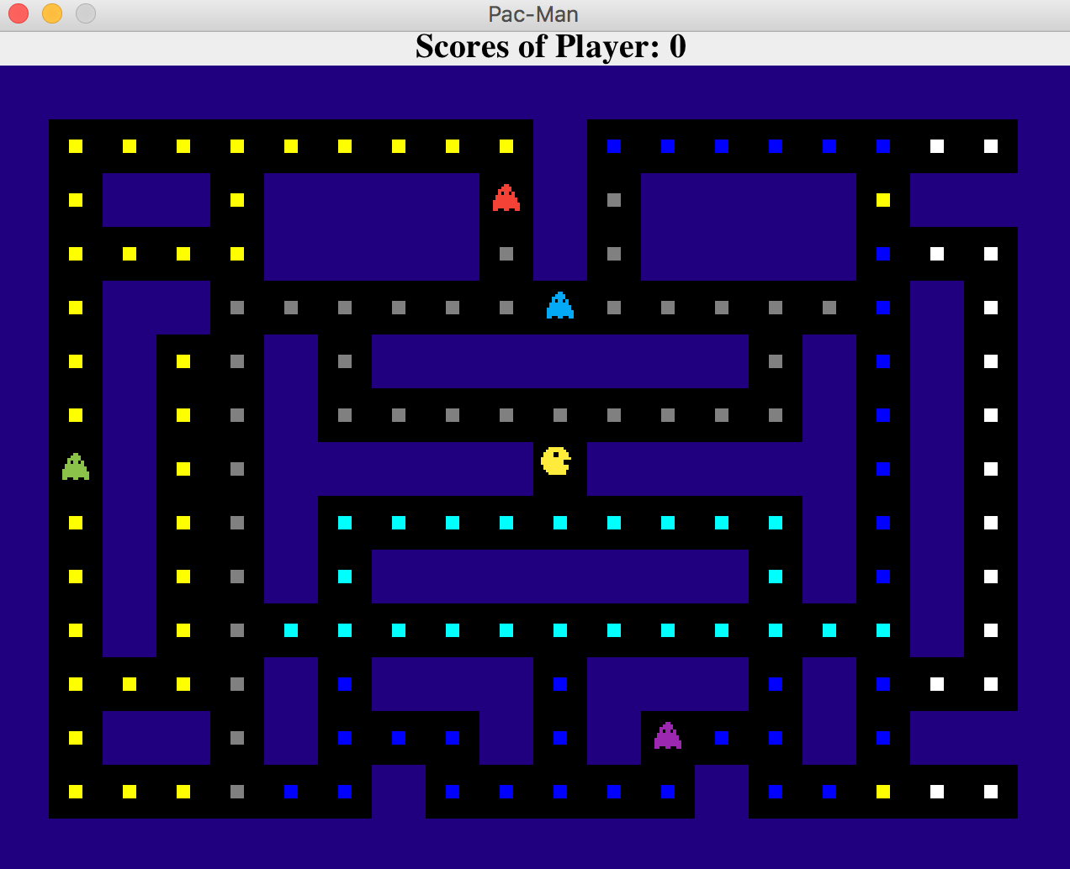

Figure.5

Then press any of arrow keys on keyboard to move the player. The arrow-up key represent moving upwards, the arrow-down key represent moving downwards, the arrow-left key represent moving left and the arrow-up key represent moving right. After moving the player one square upwards and a few squares leftwards, the board should looks like Figure.6. Coins of different color represent different points(cyan-10 points, gray-20 points, blue-30 points, yellow-40 points and white-50 points )The score of the player is 80 now because player has eaten 4 gray coins. And the coins eaten by the player should disappear from board like Figure.6.

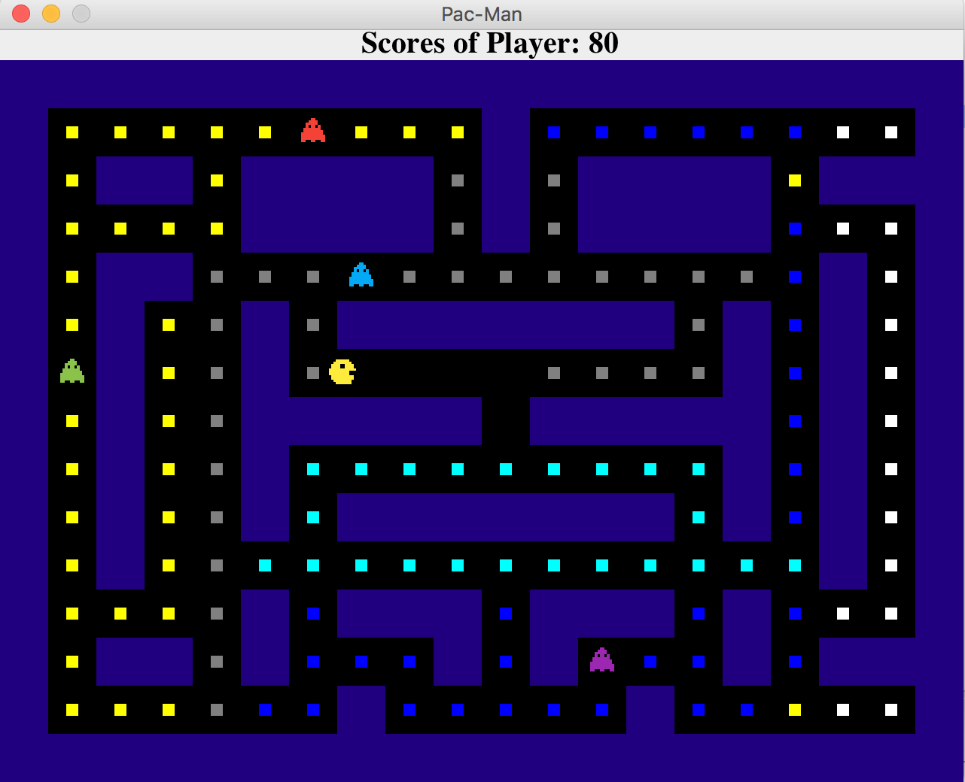

Figure.6

After moving the player in different directions, the player should expect to see a board like Figure.7. It's obviously that all enemies are gather around the player since they always move towards in a direction that makes them closer to the player.

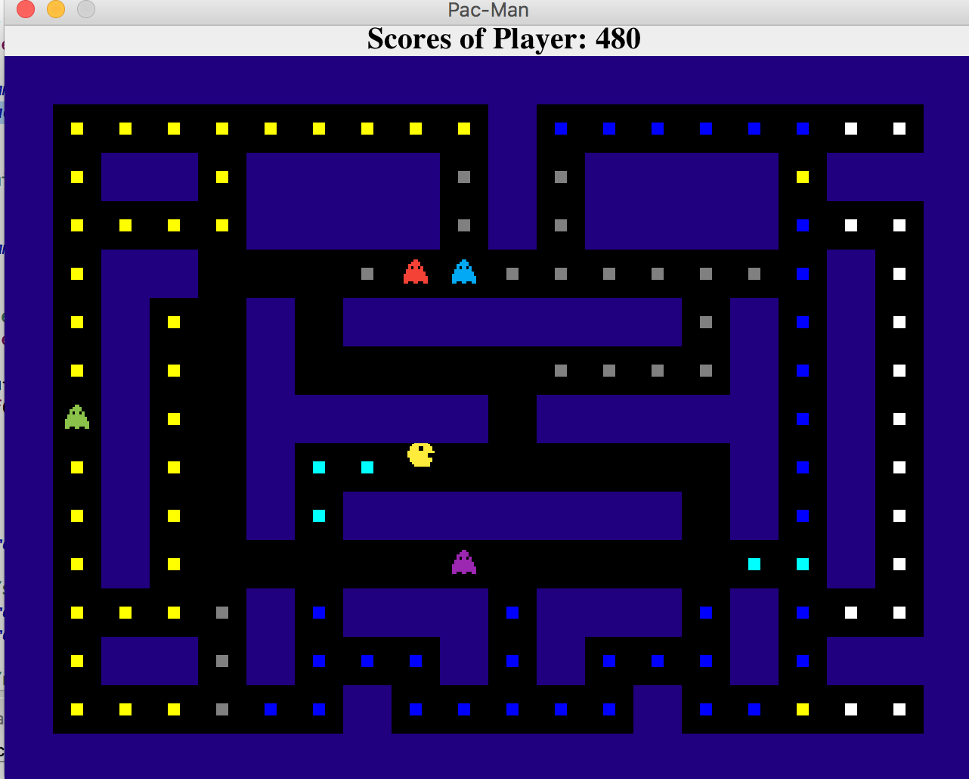

Figure.7

After the player collides with any of the enemies, a dialog window looks like Figure.8 should pop up. If the player selects "No", the game will be exited. And if the player selects "Yes", he/she should see a view looks like Figure.2 that asks the player to reselect the board size he/she wants to play with. If the player choose "15x15", the game board will looks like Figure.9. If the player choose "30x15", the game board will looks like Figure.10.

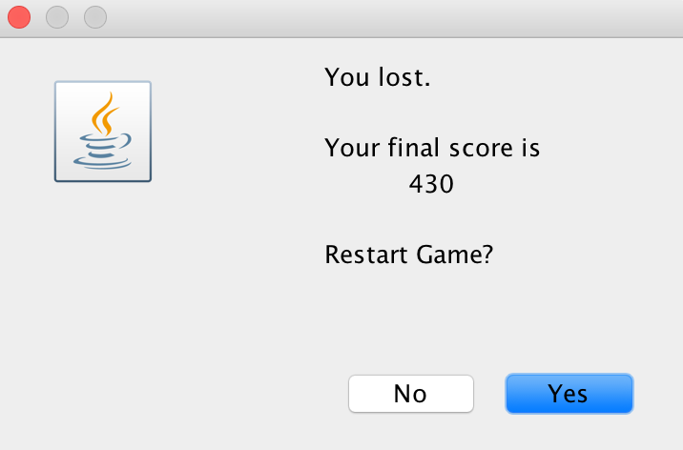

Figure.8

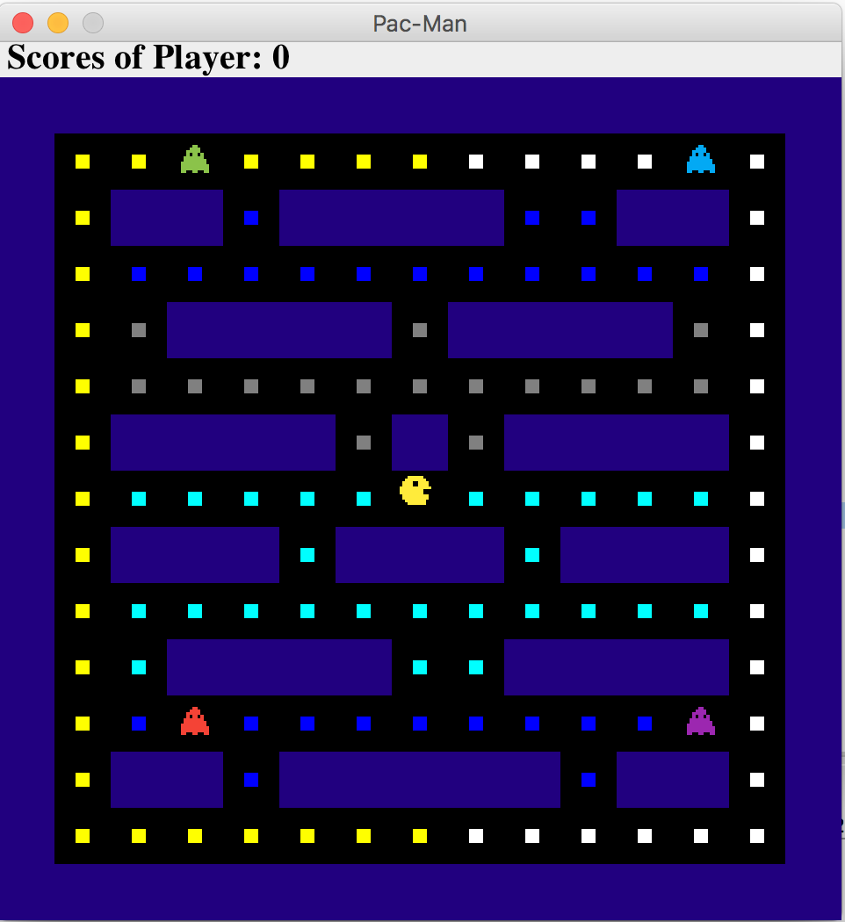

Figure.9

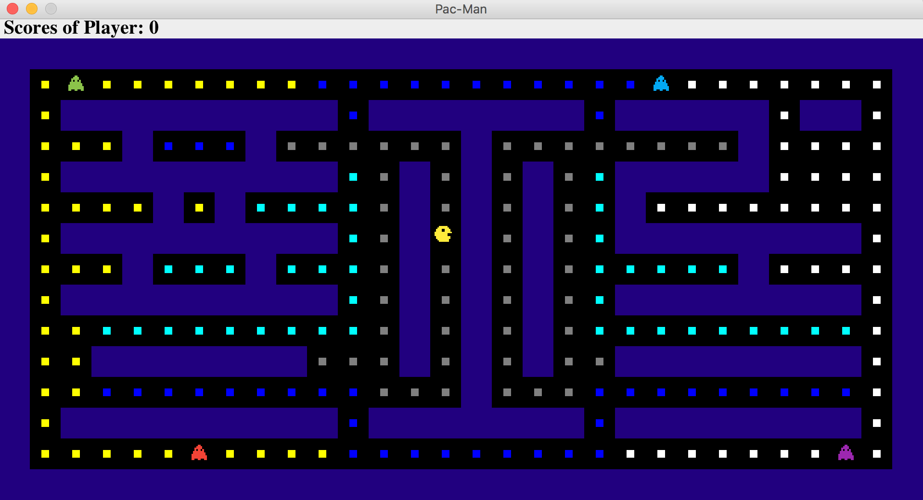

Figure.10